Lab03

Exercise 3

I.The Ip address of [www.eecs.berkeley.edu](https://eecs.berkeley.edu/) is 23.185.0.1, and the query type is a A query

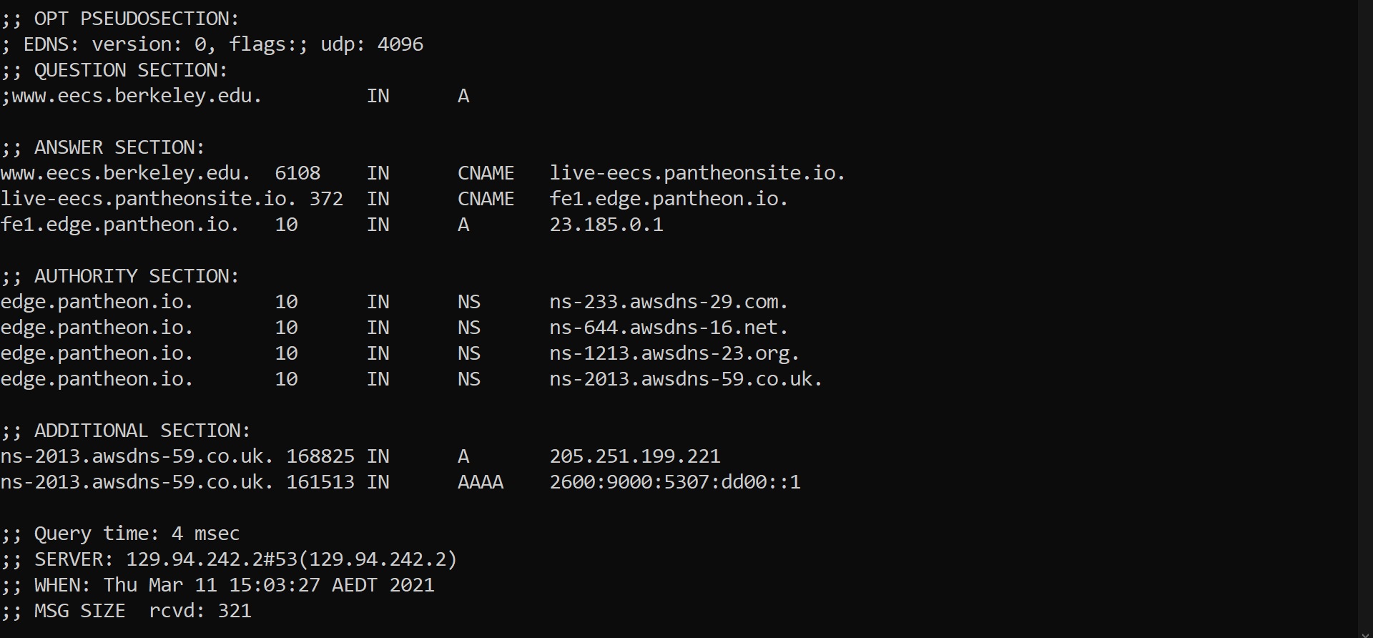

II.From running command dig [www.eecs.berkeley.edu](https://eecs.berkeley.edu/), we can see the canonical name for the[www.eecs.berkeley.edu](https://eecs.berkeley.edu/) is live-eecs.pantheonsite.io. The reason why there is an alias for a web server is because the canonical(live-eecs.pantheonsite.io) name are harder to remember than the alias name([www.eecs.berkeley.edu](https://eecs.berkeley.edu/))

III.

(Please refer to the screen shot in question I)

In the Authoritative section, there are some domain name with NS records which show other domain names available for edge.pantheon.io.

In the additional section, we can find both IPV 4(A) and IPV 6(AAAA) for the IP address of the server( ns-2013.awsdns-59.co.uk).

IV.

The IP address of the local machine(CSE virtual machine in this case) is 129.94.242.2, This Ip address can be found in the stat section.

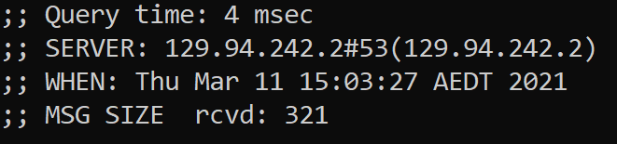

V.

The DNS name server are listed in the Authority section, and their corresponding IP address are listed in the Additional section . The NS query is used to obtain the answers

Run command dig eecs.berkeley.edu

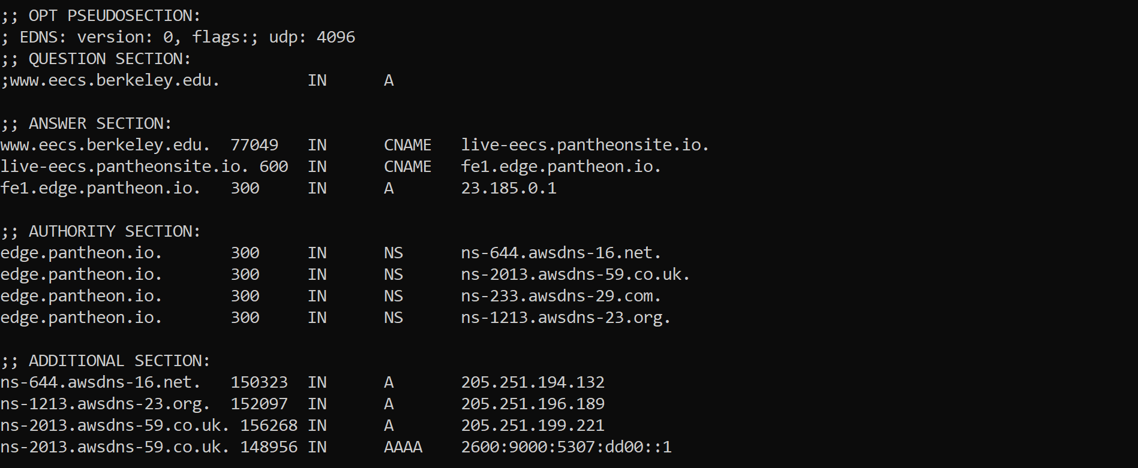

VI.

Use reverse dig to obtain the domain name associated with the IP address which is 111.68.101.54. The domain name is web server.seecs.nust.edu.pk. A PTR query is sent to obtain this associated domain name.

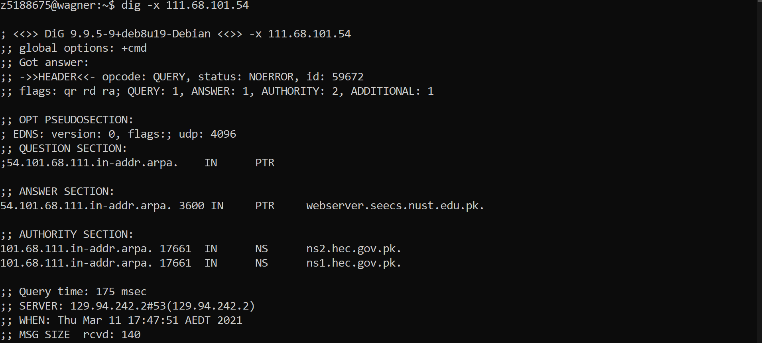

VII.

I obtained the following answering servers when I ran command dig @129.94.242.33 yahoo.com MX. In my case, there are no authoritative answers, because the query did not send back the aa flag which indicates the authoritative answers.

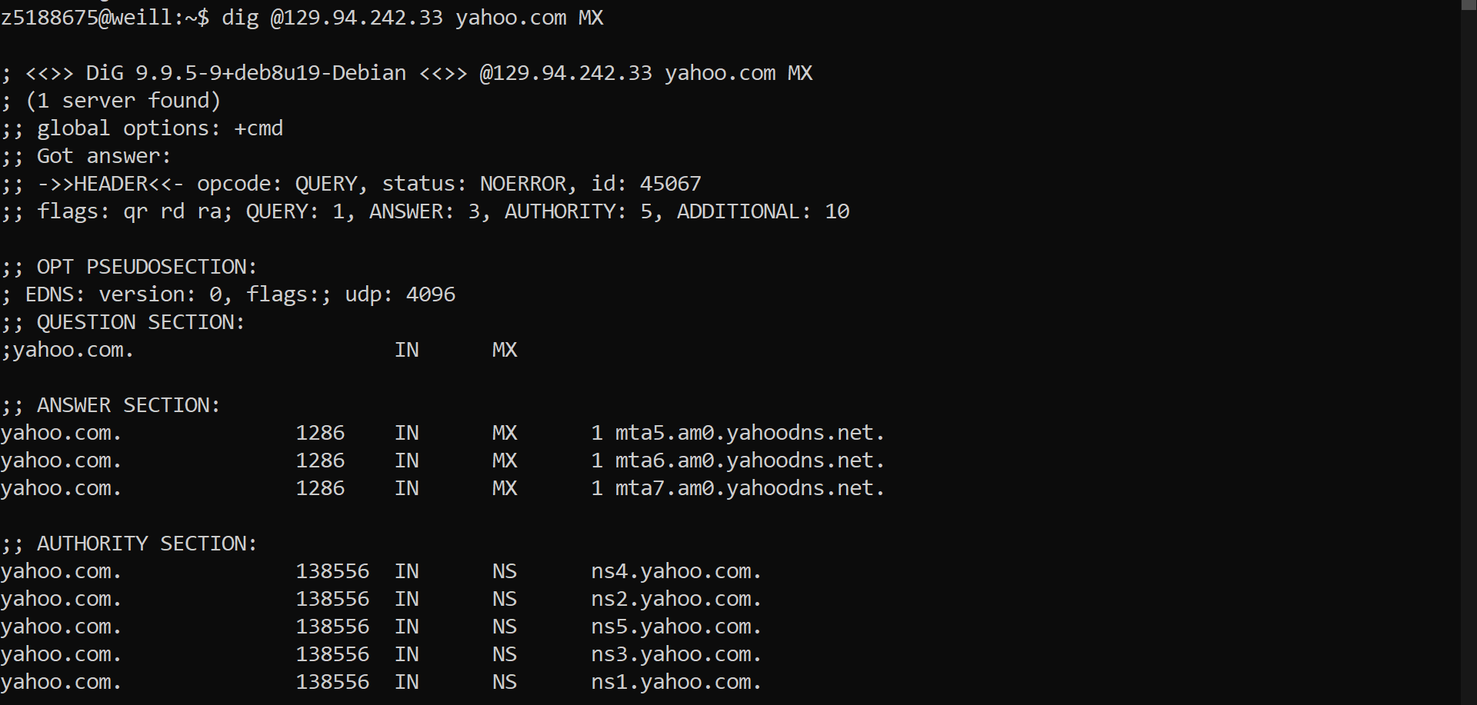

VIII.

I repeated the query by run command of dig ns-2013 .awsdns-59.co.uk(205.251.199.221)

Actual command: dig @205.251.199.221 yahoo.com MX

flags: qr rd ra; QUERY: 1, ANSWER: 1, AUTHORITY: 5, ADDITIONAL: 11

flags: qr rd ra; QUERY: 1, ANSWER: 6, AUTHORITY: 5, ADDITIONAL: 10

And i still can not see the aa flag in the query, therefore it is still non authoritative

VIIII.

To obtain the authoritative answer, first we need to find the server listed in the authoritative section of yahoo.com

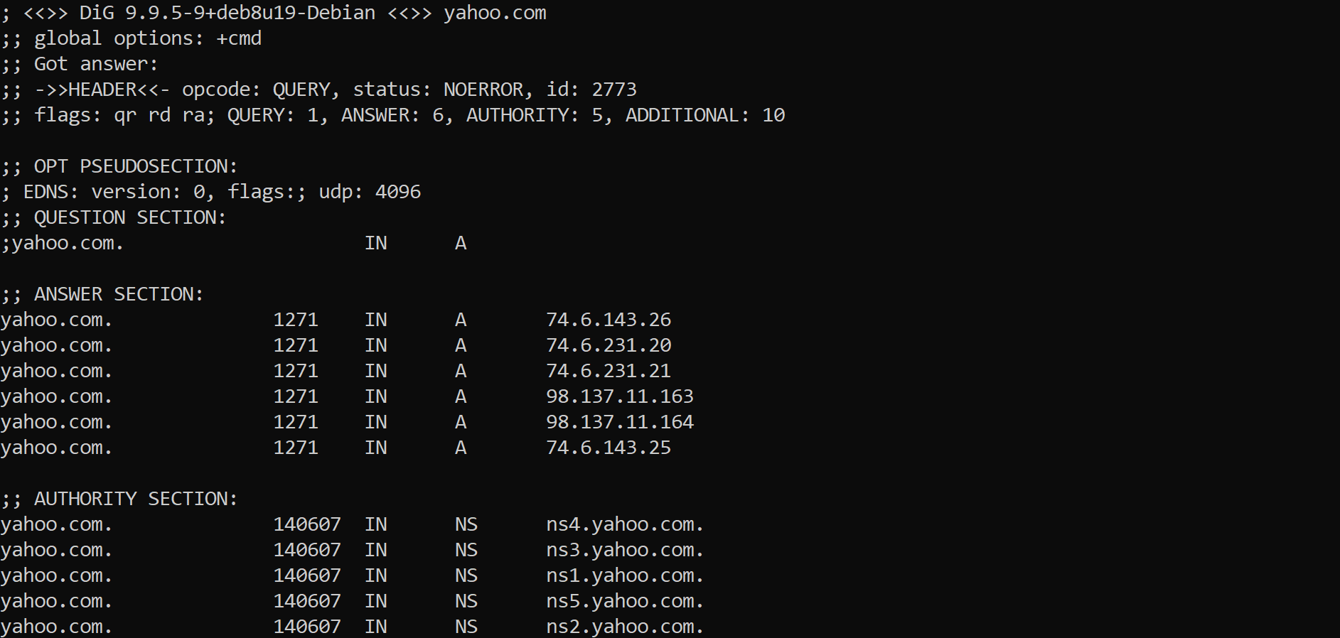

The use the IP of one of these serves as the first parameter of dig command(eg. dig ns1.yahoo.com yahoo.com MX).

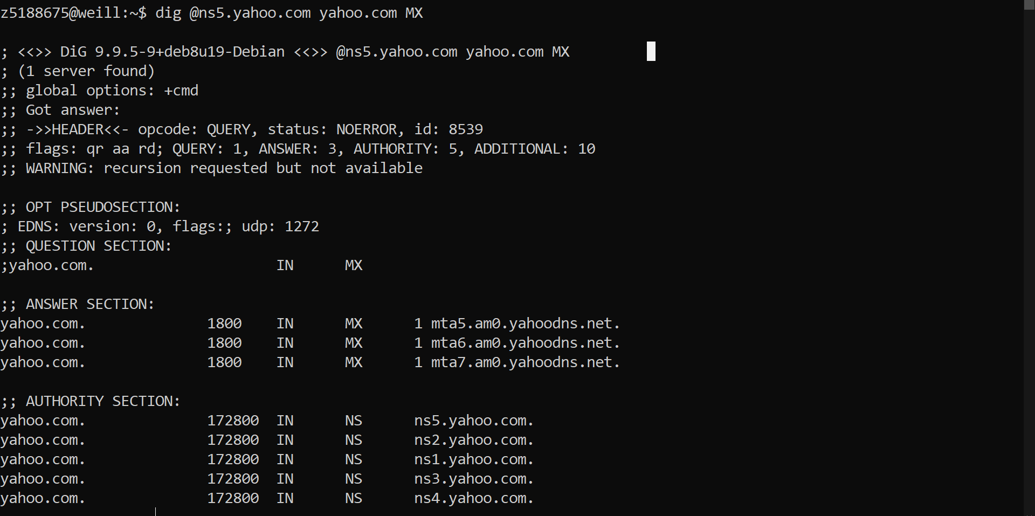

We can see the aa flag in the flag area indicating the answer is authoritative.

X.

Firstly using dig root command to obtain the root server of a.root-server.net, then use obtained root server to dig the server of .au, this gives bunch of .au serves, then use one of the .au servers to dig the .edu.au, after that repeat the process until drum01.cse.unsw.edu.au is found.

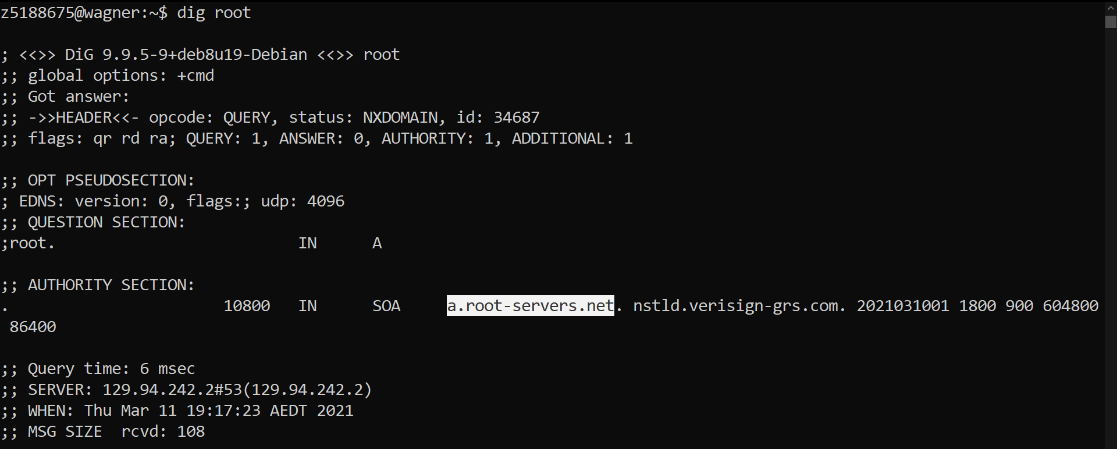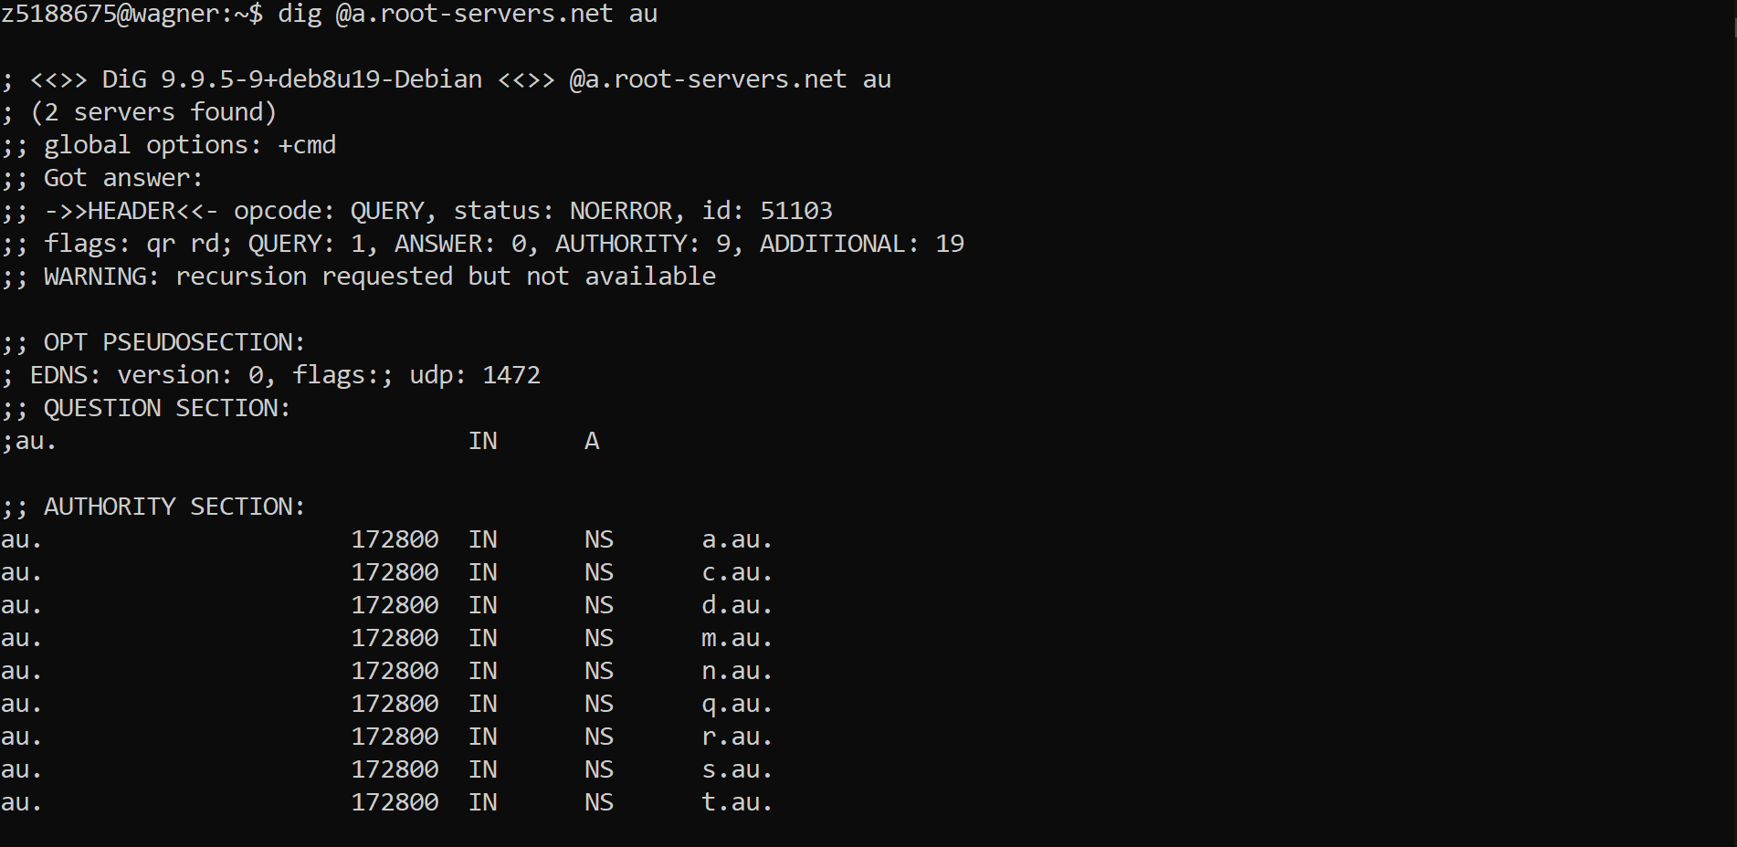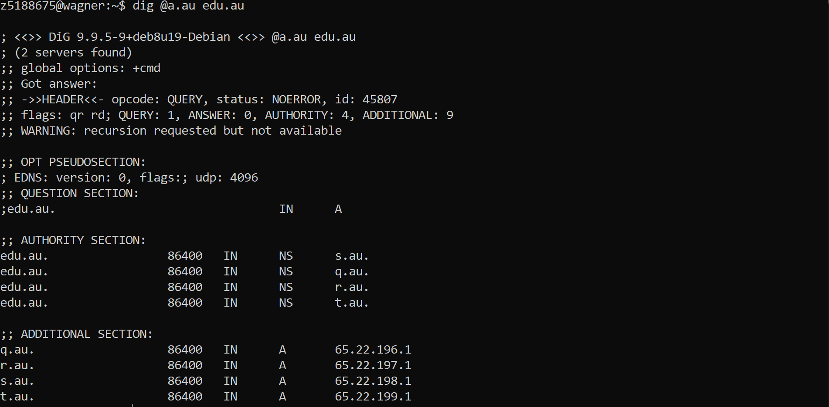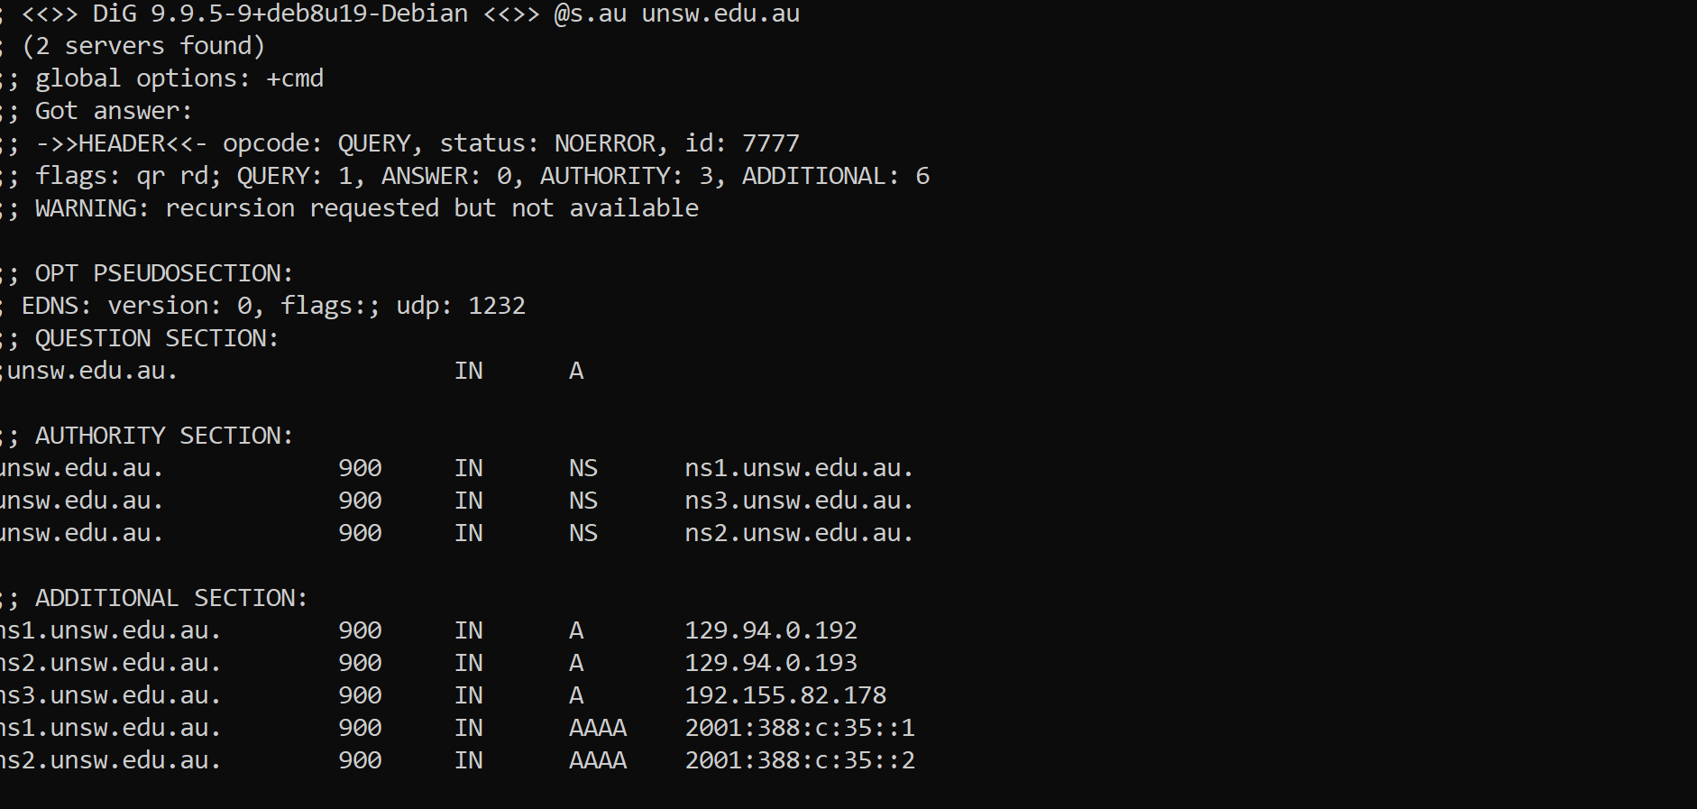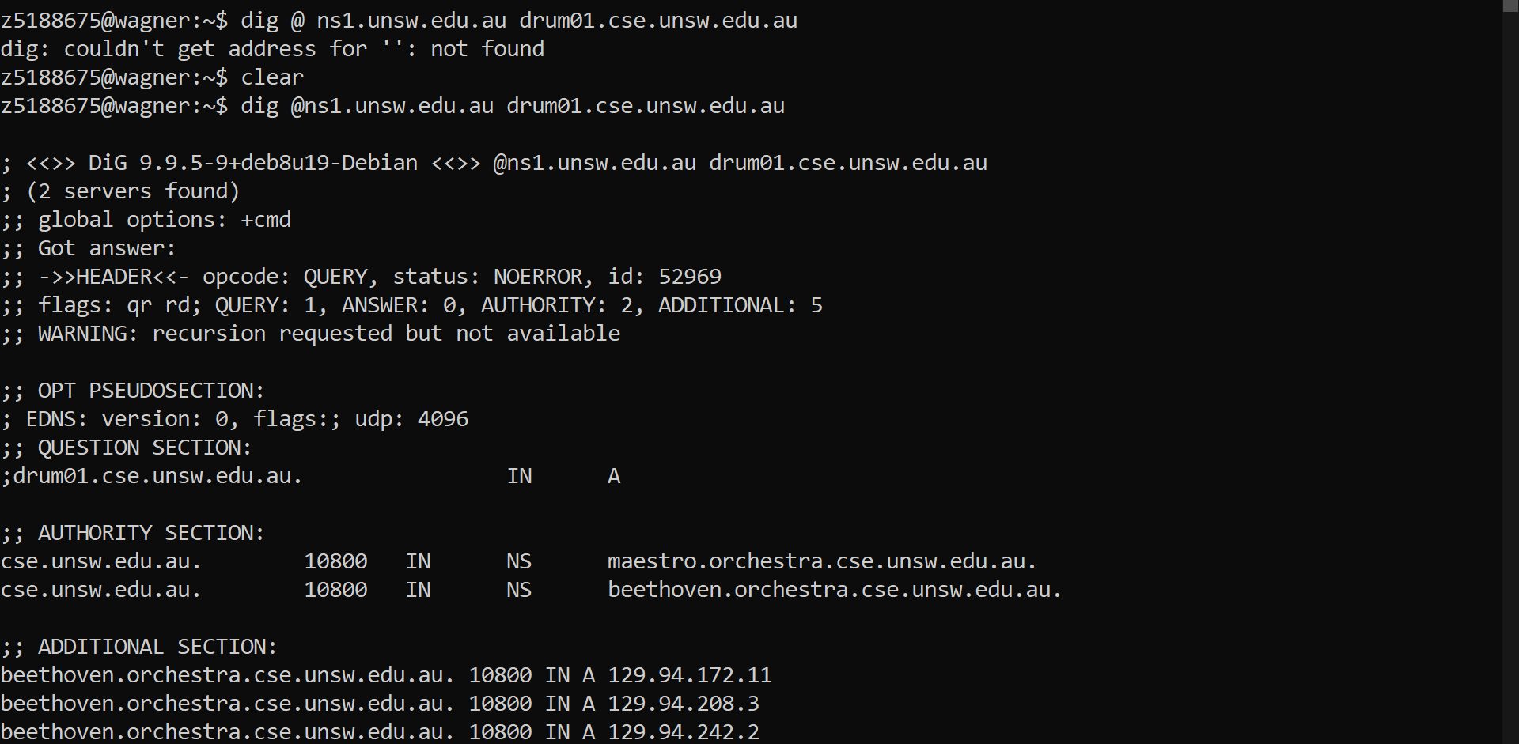

Finally it reaches drum01.cse.unsw.edu.au

XI.

Yes because one physical machine can have different name setup by using alias names.

XII.

Please use python2.7.17 to run WebServer.py

You can use the command

Python WebSever.py <port number>